**Air Quality Monitoring System**

**Inroduction:**

The potential subject area is large and the focus here is on the chronology of air pollution by human activity, identifying the main issues, their causes and the regional and global trends. Other papers in this volume, to which links are made, provide the wider context, the policies developed to address the problems and the possible futures

There are four rather different sources of evidence to provide the narrative for this account. These include written documents including early legislation, direct measurements of atmospheric composition, chemistry transport models, which simulate atmospheric composition changes from a knowledge of emissions, meteorology and chemical processing of pollutant gases, and, finally, remote sensing of the atmosphere from aircraft and space. The early documents are fascinating and provide hints at the underlying chemistry, but are entirely lacking in quantitative detail. Legal documents indicate the intent, but, for reasons elaborated later, did not significantly constrain the developing global issues until the later decades of the twentieth century. High-quality measurements of air pollutants are restricted to the last 150 years and numerical modelling to the last 40 years, leaving considerable scope for speculation on the early trends

### **1. Pre-1750 early evidence air pollution posed a risk to human health and ecosystems:**

Early humans would have been aware of at least some of the potential hazards in the air they breathed from their general discomfort in the presence of smoke and combustion gases close to open fires. The need for shelter and warmth led to fires inside shelters, and in confined structures, the exposure to potentially toxic gases and particles is considerably enhanced. Given the directly noxious properties of many combustion products (smell, and lachrymose and respiratory effects), it is surprising that so many societies had dwellings with open fires and no chimneys. The development of the chimney itself can be seen as a key milestone for indoor air quality, adopted at first in the largest houses from the twelfth century [[12](https://royalsocietypublishing.org/doi/10.1098/rsta.2019.0314#RSTA20190314C12)]. Today, indoor air pollution is an important contributor to effects on human health. All subsequent analysis here, however, is devoted to the outdoor environment.

Evidence from Greece shows that the problems of polluted air outdoors were being documented at least 2400 years ago. The book *Airs, waters and places* attributed to Hippocrates (*ca* 400 BC) suggested all sorts of illness as being related to the quality of air. The worst it seems was in cities facing damp westerly winds, where the inhabitants ‘are likely to have deep, hoarse voices, because of the atmosphere, since it is usually impure and unhealthy in such places' ([[13](https://royalsocietypublishing.org/doi/10.1098/rsta.2019.0314#RSTA20190314C13)], p. 83). Writers a little later from Imperial Rome understood the probable health impacts of smoke with Seneca (*ca* AD 63–65) referring to the problem and Frontinus (*ca* AD 96) proudly declaring how his contribution to aqueducts and fountains has helped make the air purer: ‘the causes of the unwholesome atmosphere, which gave the air of the City so bad a name with the ancients, are now removed’ ([[14](https://royalsocietypublishing.org/doi/10.1098/rsta.2019.0314#RSTA20190314C14)], p. 417). As Seneca recorded of a health break from Rome:

### **2. The development of laws to control air pollution 1273–1900:**

The earliest legislation in England was the 1273 Smoke Abatement Act, prohibiting the use of coal as it was ‘prejudicial to health’ [[22](https://royalsocietypublishing.org/doi/10.1098/rsta.2019.0314#RSTA20190314C22)]. Some mediaeval societies approached air pollution control by keeping the sources outside the city walls, a concept found in Aristotle's *Athenian Politics* and in ancient Roman regulation [[23](https://royalsocietypublishing.org/doi/10.1098/rsta.2019.0314#RSTA20190314C23)]. This practice continued in mediaeval Europe, but also Asia, notably in relation to the extensive fifteenth-century Thuriang pottery kilns, which were located in the northern lee of Si Satchanali, Thailand. These early examples of what we may now like to call ‘environmental law’ include controls on the burning of sea coal and the ‘forestry laws’ (protecting the various species of game living in the forests). Most of these examples derive from the particular whims and prejudices of individual rulers, often heavily influenced by those within the upper social echelons of society. There was no modern science involved: the problem was perhaps a visual blot on the monarch's landscape, an appalling smell or a passion for hunting. In every case, the control or prohibition was imposed without any need to resort to the scientific knowledge base of the time.

### **3. Early evidence of air pollution transport from measurements:**

There were seventeenth-century analyses of rainfall, possibly the first by Ole Borch in Denmark. These became more commonly undertaken by agriculturalists during the 1800s [[19](https://royalsocietypublishing.org/doi/10.1098/rsta.2019.0314#RSTA20190314C19)] and increasingly used worldwide [[10](https://royalsocietypublishing.org/doi/10.1098/rsta.2019.0314#RSTA20190314C10),[48](https://royalsocietypublishing.org/doi/10.1098/rsta.2019.0314#RSTA20190314C48),[49](https://royalsocietypublishing.org/doi/10.1098/rsta.2019.0314#RSTA20190314C49)], providing early evidence of inter-country exchange of pollutants from observations of contaminated snowfall. The deposition of urban sulfate in London rainfall was determined by Robert Angus Smith in 1869–1870 [[7](https://royalsocietypublishing.org/doi/10.1098/rsta.2019.0314#RSTA20190314C7)]. The number of estimates of the concentrations of substances in air increased rapidly through the nineteenth century. Russell [[50](https://royalsocietypublishing.org/doi/10.1098/rsta.2019.0314#RSTA20190314C50)] measured total PM gravimetrically in central London at 120, 360 and 860 µg m−3 in fine, dull and foggy weather, respectively [[51](https://royalsocietypublishing.org/doi/10.1098/rsta.2019.0314#RSTA20190314C51)]. Although measurements of carbon dioxide were frequent (as listed in Callendar [[52](https://royalsocietypublishing.org/doi/10.1098/rsta.2019.0314#RSTA20190314C52)]), this occurred only occasionally for trace gases such as ammonia [[31](https://royalsocietypublishing.org/doi/10.1098/rsta.2019.0314#RSTA20190314C31),[53](https://royalsocietypublishing.org/doi/10.1098/rsta.2019.0314#RSTA20190314C53)]. The early twentieth century saw the development of the deposit gauge that measured wet deposition and whatever else fell into the large glass bowl [[54](https://royalsocietypublishing.org/doi/10.1098/rsta.2019.0314#RSTA20190314C54)] and the use of lead peroxide candles to determine deposited sulfur dioxide [[55](https://royalsocietypublishing.org/doi/10.1098/rsta.2019.0314#RSTA20190314C55)]. The widespread occurrence of SO2 led to increasingly sophisticated methods that involved drawing air through Dreschel bottles (bubblers) containing solutions of iodine, hydrogen peroxide or disulfitomercurate [[56](https://royalsocietypublishing.org/doi/10.1098/rsta.2019.0314#RSTA20190314C56)].

:

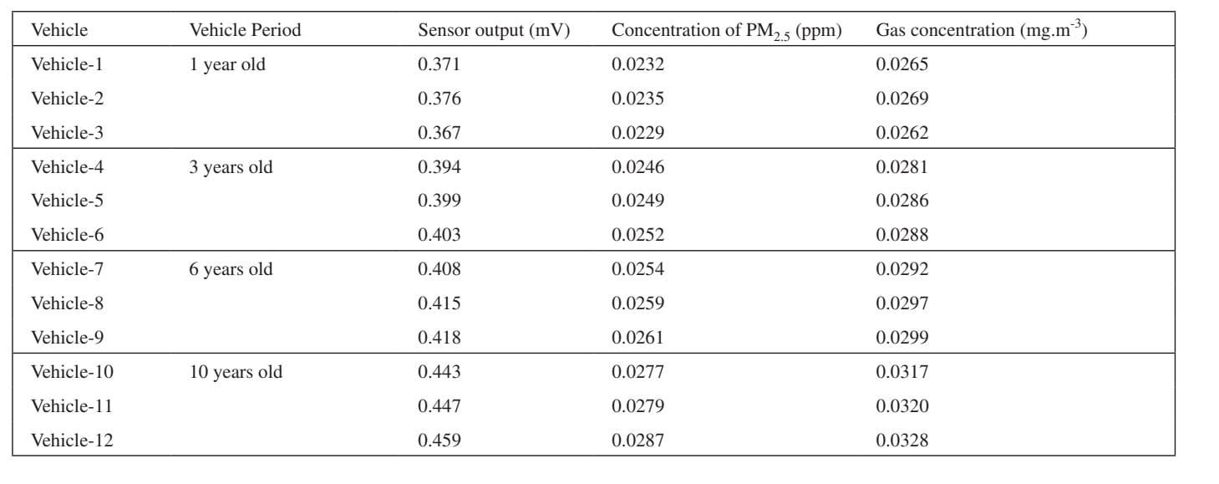

Fig 1: Environmental Parameter Measuremen

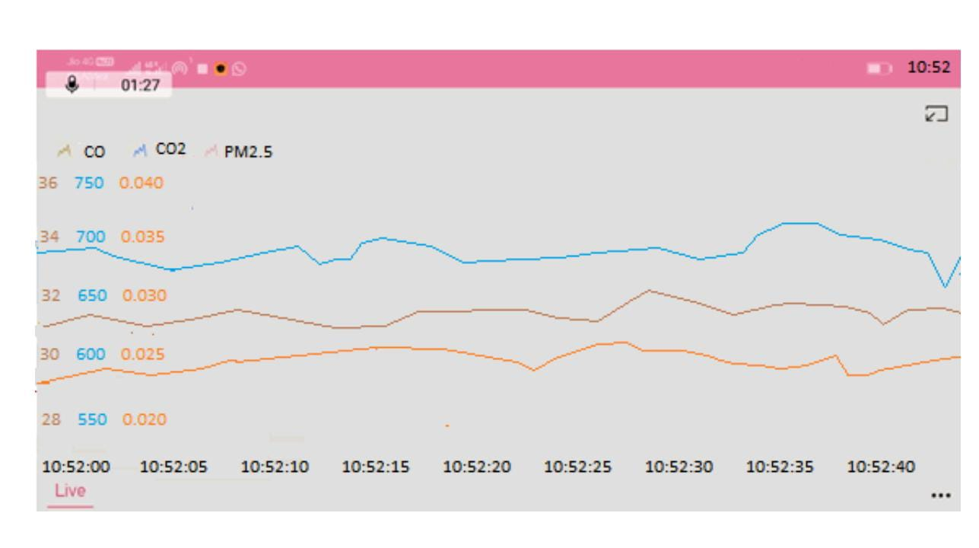

Fig 2 : Live data for CO, CO2, PM2.5 in ppm from node MCU.

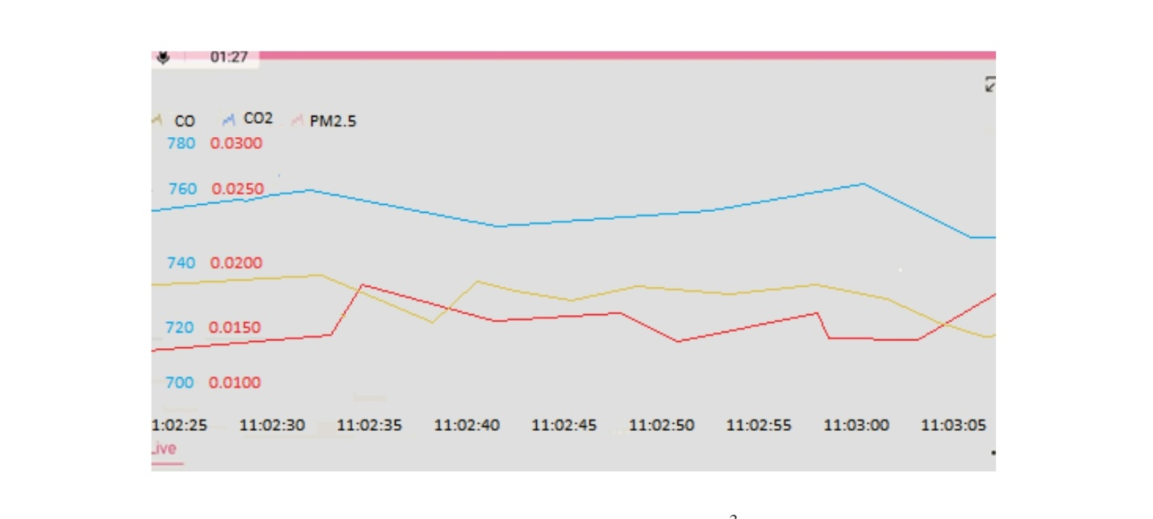

Fig 3 :Live data for CO, CO2, PM2.5 in mg.m-3  from node MCU.

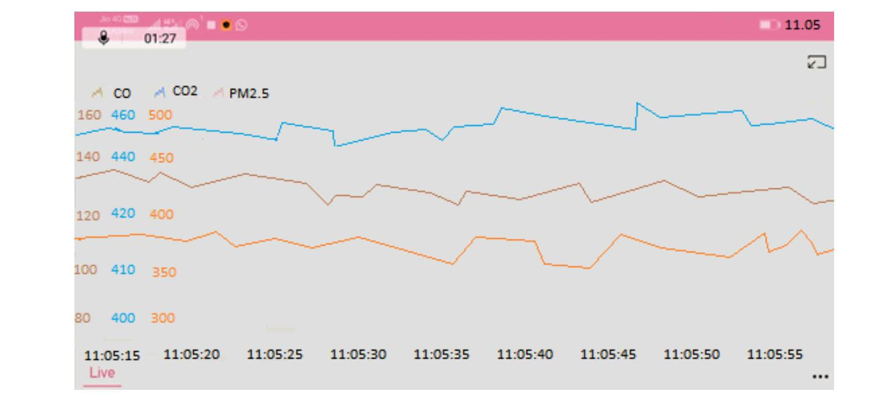

Fig 4: Live data for CO, CO PM in mV from node MCU.

Advantages.:

1.The measurements of pollution concentrations are the best characterization of a given pollutant at a given time and location.

2. The data are supported by comprehensive quality assurance program, ensuring good data of known quality VI.

Dadvantages :

1. For both gases and particulate matter , if several identical low cost system are co-located, the user should expect a high level of repeatability [R2 >0.9] and should expect to be able to adjust accuracy by ‘calibrating’ – adjusting slope and offset – against a co=located reference /equivalent station.

2. Ozone is monitored daily, but mostly during the ozone season (the warmer months, approximately April through October)